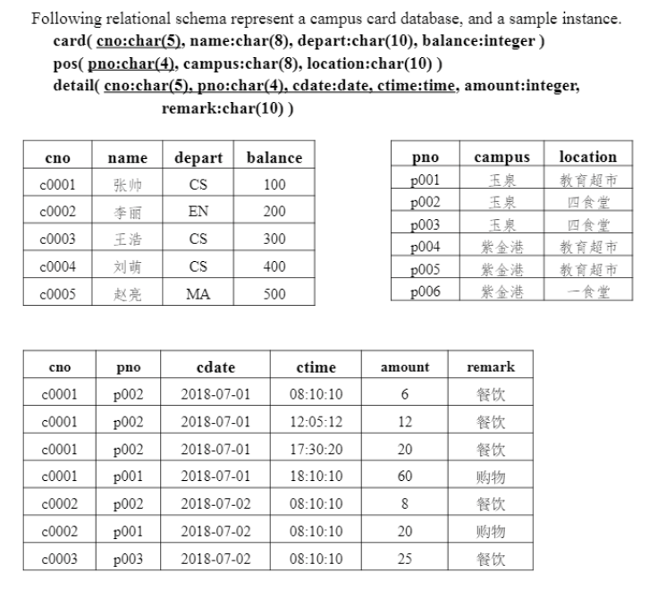

Given following SQL query on above relations：

select cno, name

from card natural join detail

where depart= ‘CS’ and (cdate , pno) in

(

select cdate, pno

from detail

where cno=‘c0002’ )

**Please answer following questions：**

1. **Transform above query to a SQL statement without nested subquery.**

Answer:

select T.cno, T.cname

from (card as T) natural join (detail as D1),

detail as D2

where T.depart = ‘CS’ and D2.cno = ‘c0002’ and

D1.cdate = D2.cdate and D1.pno = D2.pno;

1. **Transform above query to an equivalent relational algebra expression.**

Answer:

$$\prod{c1.cno, c1.name }\left(σ_{d1.cdate=d2.date⋀d1.pno=d2.pno}\left(\left(σ_{c1.depart=^{'}cs^{'}}\left(ρ_{c1}\left(card\right)\right)\right)⋈σ\left(ρ_{d1}\left(detail\right)\right)×\left(σ_{d2.cno=^{'}c{0002}^{'}}\left(ρ_{d2}\left(detail\right)\right)\right)\right)\right)$$

1. **Write a SQL statement to find out cards consumed in only one campus in 2018.**

Answer:

select cno

from detail natural join pos

where year(detail.cdate) = 2018

group by cno

having count(distinct campus) = 1;

1. **Write a SQL statement to find out the pos in “紫金港” campus that has the maximum total amount of card consumption in 2018.**

Answer:

select cno

from detail natural join pos

where pos.campus = ‘紫金港’ and year(detail.cdate) = 2018

group by pno

having sum(amount) >= all (

select sum(amount)

from detail natural join pos

where pos.campus = ‘紫金港’ and year(detail.cdate) = 2018

group by pno

);

**(5)Write a sequence of SQL statements to complete following transaction:card “c0002” consumes 20 at pos “p001” at 2018-07-02 08:08:08.**

Answer:

update card set balance = balance-20 where cno = ‘c0002’;

Insert into detail(cno, pno, cdate, ctime, amount)

values(‘c0002’, ‘p001’, ‘2018-7-02’, ’08:08:08’, ‘20’);

commit;